**International Institute Of Professional Studies**

**2020-2021**

**Department of Information Technology**

**AI Based Vision Analyzer**

A Major/Minor Project Report

Submitted in partial fulfillment of requirement of the

Degree of

**MASTER OF TECHNOLOGY**

**in**

**INFORMATION TECHNOLOGY AND ENGINEERING**

BY

**Aashutosh Bansal (IT-2K17-02)**

**Sulbha Mishra (IT-2K17-57)**

Under the Guidance of

**Mr. Shaligram Prajapat Sir**

**Report Approval**

The project work **“AI Based Vision Analyzer”** is hereby approved as a creditable study of an engineering/computer application subject carried out and presented in a manner satisfactory to warrant its acceptance as prerequisite for the Degree for which it has been submitted.

It is to be understood that by this approval the undersigned do not endorse or approved any statement made, opinion expressed, or conclusion drawn there in; but approve the “Project Report” only for the purpose for which it has been submitted.

Internal Examiner

Name:

Designation:

Affiliation:

External Examiner

Name:

Designation:

Affiliation:

**Declaration**

I/We hereby declare that the project entitled **“AI Based Vision Analyzer”** submitted in partial fulfillment for the award of the degree of Bachelor of Technology/Master of Computer Applications in ‘Computer Science’ completed under the supervision of **Shaligram sir, Assistant Professor(CSE),** Faculty of Engineering, International Institute of professional studies, DAVV Indore is an authentic work.

Further, I/we declare that the content of this Project work, in full or in parts, have neither been taken from any other source nor have been submitted to any other Institute or University for the award of any degree or diploma.

**Sulbha Mishra (IT-2K17-57)**

**Aashutosh Bansal (IT-2K17-02)**

**Certificate**

We, **Sulbha Mishra (IT-2K17-57), Aashutosh Bansal (IT-2K17-02)**  certify that the project entitled **“AI Based Vision Analyzer”** submitted in partial fulfillment for the award of the degree of Master of Technology by **Sulbha Mishra, Aashutosh Bansal** is the record carried out by them under my/our guidance and that the work has not formed the basis of award of any other degree elsewhere.

________________________________

Mr. Shaligram Prajapat

Dept. of M.TECH

International Institute of professional studies, DAVV, Indore

**Acknowledgements**

I would like to express my deepest gratitude to Honorable Chancellor, **Shri R C Mittal,** who has provided me with every facility to successfully carry out this project, and my profound indebtedness to **Prof. (Dr.) Sunil K Somani,** Vice Chancellor, Medi-Caps University, whose unfailing support and enthusiasm has always boosted up my morale. I also thank **Prof. (Dr.) D K Panda,** Dean, Faculty of Engineering, Medi-Caps University, for giving me a chance to work on this project. I would also like to thank my Head of the Department **Prof. (Dr.) Suresh Jain** for his/her continuous encouragement for betterment of the project.

I express my heartfelt gratitude to my **Internal Guide, Mr. Yogesh Kakde, Assistant Professor, Department ofComputer science & Engineering, MU**. without whose continuous help and support, this project would ever have reached to the completion.

It is their help and support, due to which we became able to complete the design and technical report.

Without their support this report would not have been possible.

**Sulbha Mishra, Aashutosh Bansal**

M.Tech. IV Year

Department of Information Technology Engineering

M. Tech

International Institute of professional studies, DAVV

**Abstract**

There has been a huge progress in computer vision since last decade. AI is an important component of this system. In this project we are providing a model of surveillance system which gives artificial intelligence to the camera. We have given the camera an ability to detect objects, count the number of people in a particular region of a video. This is called object tracking which requires object detection. The main idea is to track customers and know their interest in a particular product or in which region they are standing. This would analyse a particular area (region) with given video thereby making the system cost efficient and suitable for practical applications. The paper includes image processing techniques which will be useful for the camera to detect and count objects. We have implemented this system in ideal conditions considering the area is less populated. This project will implement a prototype for smart object detection which will help in marketing of products and making supermarkets smarter and more advanced.

**Table of Contents**

|  |  |  |
| --- | --- | --- |
|  |  | **Page No.** |
|  | Report Approval |  |
|  | Declaration |  |
|  | Certificate |  |
|  | Acknowledgement |  |
|  | Abstract |  |
|  | Table of Contents |  |
|  | List of figures |  |
| Chapter 3 | System Analysis |  |
|  | 3.1 ER-Diagram | 1 |
|  | 3.2 Data Flow Diagram | 2 |
|  | 3.3 Flowcharts | 3 |
|  | 3.4 UML Diagram | 4 |
|  | 3.5 Decision Tree | 5 |
|  | 3.6 Decision Table | 6 |

**SYSTEM ANALYSIS**

**3.1 ER-Diagram-**



**3.2 Data Flow Diagram-**



**3.3 Flow Chart**

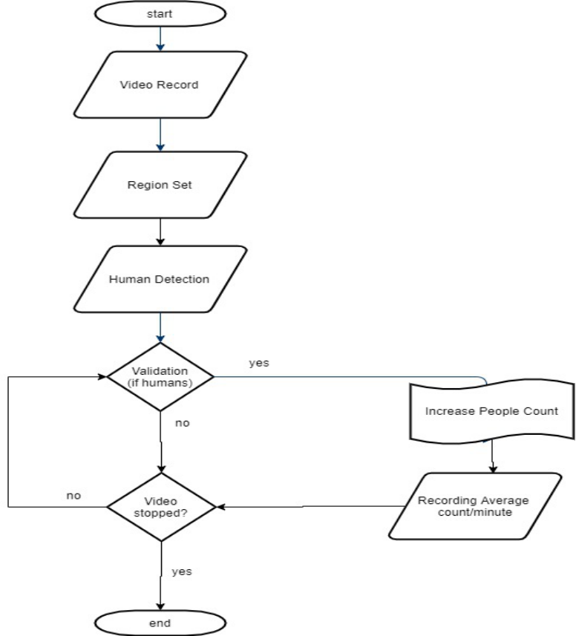

**3.4 UML Diagram**

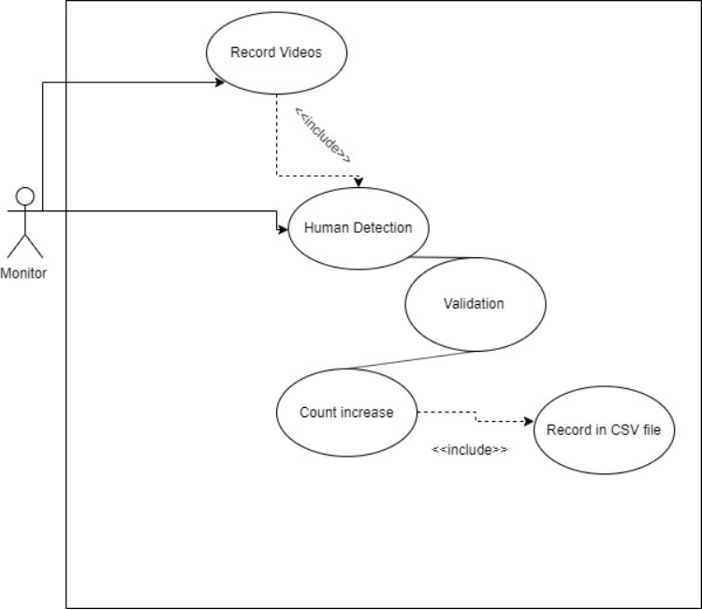

**3.5 Decision Tree**



**3.6 Decision Table**

Login in app by manager of supermarket -

|  |  |  |  |  |
| --- | --- | --- | --- | --- |
| Email | F | T | F | T |
| Password | F | F | T | T |
| Expected Result | Error: please enter email | Error: please enter password | Error: please enter email | Login process |